2022 ACSM CEC Certificate
____________ ____________

Participant Name

New England Chapter of the American College of Sports Medicine
Organization

"Game Changers”

Course Title

October 13 and 14, 2022

Rhode Island Convention Center, Providence, RI
Date and Location

650388 13
Approved Provider Number CECs Awarded

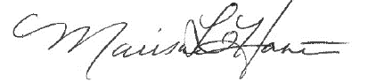
Marisa Hastie, PhD
Program Chairperson

