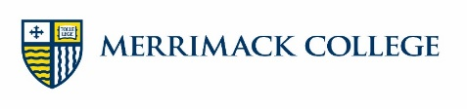
Hotel Partners of Merrimack College

Andover Inn
4 Chapel Ave
Andover, MA 01810
978-775-4900
Contact: Nicolette DeVito

Book online at: www.andoverinn.com
Online reservation code: MCC

Family Rates: Ask for Merrimack College Rate.

Courtyard by Marriott
10 Campanelli Dr.
Andover, MA 01810
978-794-0700

Book online at: www.marriott.com
Call to make reservation.

Family Rates: Ask for Merrimack College Rate.

Sonesta ES Suites
4 Tech Drive
Andover, MA 01810
978-686-2000

*Includes hot breakfast

Book online at: https://www.sonesta.com
Online reservation code: MERI

Family Rates: Ask for Merrimack College Rate.

Holiday Inn Express
224 Winthrop Ave
Lawrence, MA 01843
978-975-4050

Book online at: www.igh.com/holidayinnexpress
Online reservation code: 100235817

Family Rates: Ask for Merrimack College Rate.

La Quinta Inn & Suites
131 River Road
Andover, MA 01810
978-685-6200

*Includes hot breakfast

Book online at: www.wyndhamhotels.com/laquinta
Call to make reservation.

Family Rates: Ask for AAA Rate.

Springhill Suites
550 Minuteman Road
Andover, MA 01810
978-688.8200

*Includes hot breakfast

Book online at: www.marriott.com
Call to make reservation.

Family Rates: Ask for Merrimack College Rate.

