2017 ACSM CEC Certificate

____________ ____________

Participant Name

New England Regional Chapter
Organization

"Bridging the Gap: Translation to Application”

Course Title

October 19-20, 2017

Date

Rhode Island Convention Center, Providence, Rhode Island

Location

650388 13.5
Approved Provider Number CECs Awarded
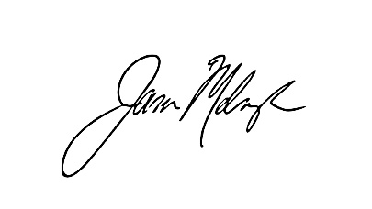
Jason Melnyk, PhD
Program Chairperson

