2015 ACSM CEC Certificate

____________ ____________

Participant Name

New England Regional Chapter
Organization

"Fueling Curiosity: Seeking Knowledge to Advance Health"

Course Title

650388 13.5
Approved Provider Number CECs Awarded

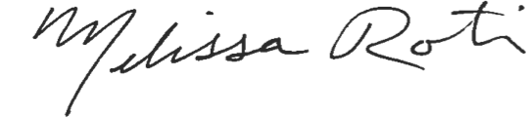
Melissa Roti, PhD, FACSM
Program Chairperson

